**Query 1 sem index:**

SELECT a.idt_employee, a.name_employee, t.idt_team, t.name_team

FROM(

SELECT e.name_employee, e.idt_employee, d.idt_project

FROM Employee as e

INNER JOIN Department as d ON d.idt_department = e.idt_department

) as a

LEFT JOIN Team as t ON t.idt_project = a.idt_project

ORDER BY t.name_team;

Relatório do plano de consulta a partir do comando explain do Postgress:

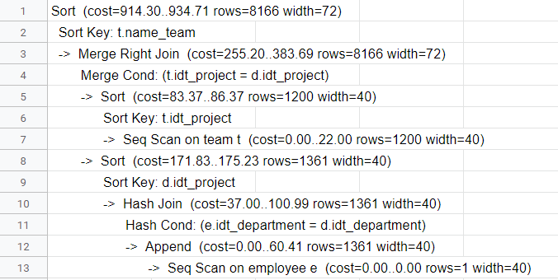

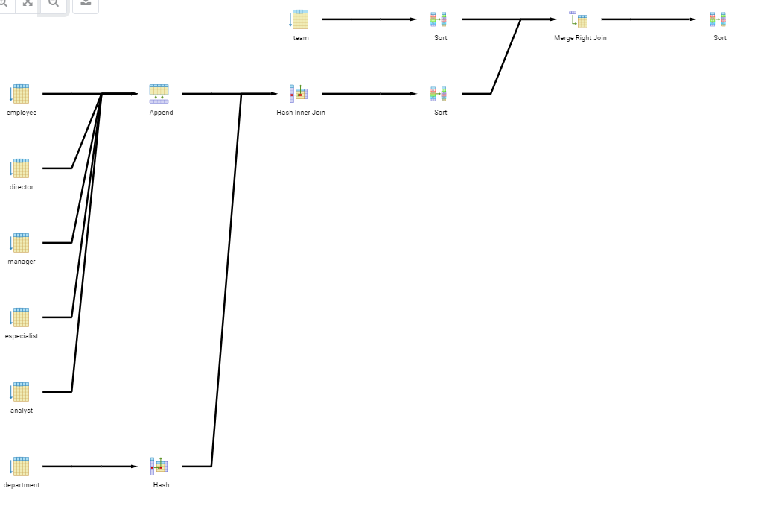

**query 1 com index:**

CREATE INDEX indicePrimeiraQuery

ON Employee (idt_employee, name_employee);

CREATE INDEX indicePrimeiraQueryTeam

ON Team (idt_team, name_team);

Relatório do plano de consulta a partir do comando explain do Postgress:

